**Sunday, October 15, 2023**

**Worship 11:00am – Pentecost 20**

**Welcome & Announcements**

**Worship Songs**

**Prayer of the Day**

**Children’s Message**

**Scripture: Philippians 4:1-9 Spark Bible**

**Prayers of the People**

**Fellowship Time**

**Offering & Song**

**Scripture: Philippians 3:12-16** *The Message*

**Message**

**Song of the Day**

**Holy Communion**

**Sending Song**

**Blessing**

* **Worship services are intended to welcome children and their families into time with God. Children are welcome to stay with parents for worship.**
* **Power Zone (Sunday School) – PowerZone will be meeting in classroom A today.**
* **Today’s lesson is – “Rejoice in the Lord Always”**

* **Prayer Support: Requests for prayer or pastoral needs can be made in confidence via email:** [**prayer@makingfaithmatter.ca**](mailto:prayer@makingfaithmatter.ca)

**October’s music has been sponsored by**

**Jan Gerdes remembering her Mom Vivian.**



**October’s hospitality has been sponsored by Betty & Gordon McRae for Betty’s birthday!**



**October’s PowerZone has been sponsored this month by Jan Gerdes**



**October’s**

**bulletin has been sponsored by Gordon & Betty McRae**

**“Thanksgiving giving thanks”**



**#MakingFaithMatter**

**On October 29th, Reformation Sunday, we are going to be receiving new members and inviting members to recommit to their membership.**

**If you are interested in becoming a member and can’t attend on October 29th please contact Pastor Phil. (email and contact number are on the back of every bulletin)**



**We will be having cake in the lobby after service to celebrate.**

**Pastor Phil is offering a couple of opportunities to read & study the Bible:**

**Dwelling in the Word 9:30-10:30**

**every Sunday in the Prayer Chapel**

**this study will focus on prayerful reading of Scripture and discussing what we hear God telling us.**



**Digging into the Word 10:00-11:30**

**every Tuesday in the Sanctuary is an introduction to Bible study for both experienced and inexperienced readers of the Bible. If you are curious and want to learn about the Bible, this discussion**

**is for you!**

It is time to renew your **Canada Lutheran** **Magazine**. Subscriptions must be received by October 31st if you want to renew or start receiving this terrific magazine. We have a discounted rate of $18.11 for a year. Make cheques payable to First Lutheran Church. For more information please see Liz.

It is time to renew your **Canada Lutheran** **Magazine**. Subscriptions must be received by October 31st if you want to renew or start receiving this terrific magazine. We have a discounted rate of $18.11 for a year. Make cheques payable to First Lutheran Church. For more information please see Liz.

**Join us for our Pub Night next Sunday October 29th from**

**5:30 – 7:00 at the Dorset**

**(37th street & 17th avenue)**



**Soup Social is this Thursday, October 19th.**

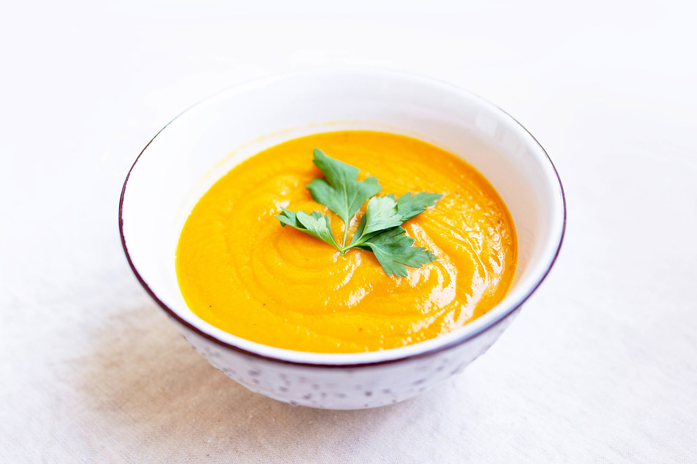

**Come and join us @ noon for soup and conversation.**

**Please signup or let Kelly know that you will be coming so we have enough soup☺**

**If you are interested in helping start a small group please contact Pastor Phil or**

**phone Brent @ 403-771-3338**



**First Lutheran’s Vision Statement.**

**First Lutheran Church is a dynamic**

**Christian community that is making faith matter**

**in a constantly changing world.**

Facebook.com/FirstLutheranChurchCalgary

@FLCCalgary

Youtube.com/FirstLuthCalgary

FLCCalgary

**Visit us online at www.makingfaithmatter.ca**

**Want to contact us?**

**Office Hours: Monday – Wednesday, 10am-3pm**

**Office Phone 403-242-4544**

**Phil –** Pastor: Local 206 Cell number: 403-813-6797

[**phil@makingfaithmatter.ca**](mailto:phil@makingfaithmatter.ca)

**Kelly** – Financial Assistant & Property Manager:Local 207

Christmas Eve Candlelight Services

December 24th

at 3, 5 and 7pm.

Communion will

be served at all

three services.

All are welcome.

[**kelly@makingfaithmatter.ca**](mailto:kelly@makingfaithmatter.ca)

**Yvonne –** Worship Director: Local 202

[**worship@makingfaithmatter.ca**](mailto:worship@makingfaithmatter.ca)

**Sarah** – Youth Co-ordinator

[**youth@makingfaithamtter.ca**](mailto:youth@makingfaithamtter.ca)

**Council –** Council Members

[**council@makingfaithmatter.ca**](mailto:council@makingfaithmatter.ca)

**Prayer –** Prayer Chain

[**prayer@makingfaithmatter.ca**](mailto:prayer@makingfaithmatter.ca)

**First Lutheran Church**

**7102 – 14th Avenue SW**

**Calgary, Alberta T3H 4G7**

**Tel: 403-242-4544**

[**www.makingfaithmatter.ca**](http://www.makingfaithmatter.ca)