**Sunday, November 05, 2023**

**Worship 11:00am – All Saints Sunday**

**Welcome & Announcements**

**Worship Songs**

**Prayer of the Day**

**Children’s Message**

**Scripture: Matthew 23:1-12** *Spark Bible*

**Prayers of the People**

**LCM Presentation from Pastor Margret Propp**

**Fellowship Time**

**Offering & Worship Song**

**Scripture: Matthew 23:1-12** *The Message*

**Reflection**

**Song of the Day**

**Holy Communion**

**Sending Song**

**Blessing**

* **Worship services are intended to welcome children and their families into time with God. Children are welcome to stay with parents for worship.**
* **Power Zone (Sunday School) – PowerZone will be meeting in classroom A today.**
* **Today’s story is – “Pharisees Show, Jesus Tells”**

* **Prayer Support: Requests for prayer or pastoral needs can be made in confidence via email:** [**prayer@makingfaithmatter.ca**](mailto:prayer@makingfaithmatter.ca)

**November’s music has been sponsored by Betty & Gordon McRae to celebrate their daughter Marla’s birthday**



**November’s hospitality has been sponsored by Irene Campbell in memory of Grant. **

**November’s PowerZone has been sponsored this month in honour of Marissa’s & McKenzie’s birthday**



**November’s**

**bulletin has been sponsored by**

**Irene Campbell in memory of Darcie.**



**#MakingFaithMatter**

**Today, November 5th, we welcome Pastor Margret Propp who will be here explaining what Lutheran Campus Ministry is about.**

**This ministry is active at University of Calgary,**

**Mount Royal University**

**and SAIT.**



**We will be accepting donations for Lutheran Campus Ministry, LCM, if you wish to add extra to your normal offering this month just put LCM and the amount on your envelope.**

The Men's Lunch is next week!



Lunch is noon on Thursday, November 9th at Moxies Downtown.

Please text Wayne at

403-991-3506 and let him know you are attending so he can reserve a table.

See you there!

It is time to renew your **Canada Lutheran** **Magazine**. Subscriptions must be received by October 31st if you want to renew or start receiving this terrific magazine. We have a discounted rate of $18.11 for a year. Make cheques payable to First Lutheran Church. For more information please see Liz.

It is time to renew your **Canada Lutheran** **Magazine**. Subscriptions must be received by October 31st if you want to renew or start receiving this terrific magazine. We have a discounted rate of $18.11 for a year. Make cheques payable to First Lutheran Church. For more information please see Liz.

**Digging into the Word 10:00-11:30**

**every Tuesday in the Sanctuary is an introduction to Bible study for both experienced and inexperienced readers of the Bible.**

**If you are curious and want to learn about the Bible please join**



**The next Soup Social Is November 16th**

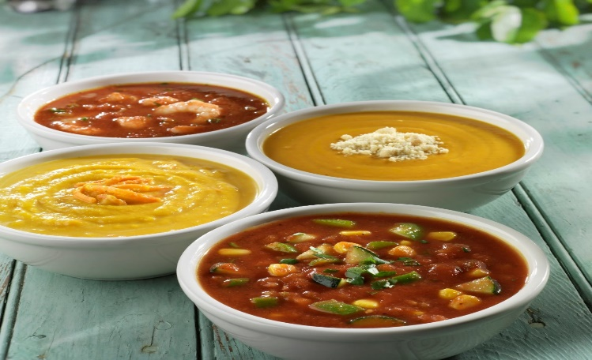

**If you are interested in helping start a small group please contact Pastor Phil or**

**phone Brent @ 403-771-3338**



**Bottle and can collection is ongoing.**

**Please drop your bottles off by the**

**shed closest to the garbage bin.**

**Your support is appreciated!**



**$663.10 has been collected in 2023.**

**First Lutheran’s Vision Statement.**

**First Lutheran Church is a dynamic**

**Christian community that is making faith matter**

**in a constantly changing world.**

Facebook.com/FirstLutheranChurchCalgary

@FLCCalgary

Youtube.com/FirstLuthCalgary

FLCCalgary

**Visit us online at www.makingfaithmatter.ca**

**Want to contact us?**

**Office Hours: Monday – Wednesday, 10am-3pm**

**Office Phone 403-242-4544**

**Phil –** Pastor: Local 206 Cell number: 403-813-6797

[**phil@makingfaithmatter.ca**](mailto:phil@makingfaithmatter.ca)

**Kelly** – Financial Assistant & Property Manager:Local 207

Christmas Eve Candlelight Services

December 24th

at 3, 5 and 7pm.

Communion will

be served at all

three services.

All are welcome.

[**kelly@makingfaithmatter.ca**](mailto:kelly@makingfaithmatter.ca)

**Yvonne –** Worship Director: Local 202

[**worship@makingfaithmatter.ca**](mailto:worship@makingfaithmatter.ca)

**Sarah** – Youth Co-ordinator

[**youth@makingfaithamtter.ca**](mailto:youth@makingfaithamtter.ca)

**Council –** Council Members

[**council@makingfaithmatter.ca**](mailto:council@makingfaithmatter.ca)

**Prayer –** Prayer Chain

[**prayer@makingfaithmatter.ca**](mailto:prayer@makingfaithmatter.ca)

**First Lutheran Church**

**7102 – 14th Avenue SW**

**Calgary, Alberta T3H 4G7**

**Tel: 403-242-4544**

[**www.makingfaithmatter.ca**](http://www.makingfaithmatter.ca)