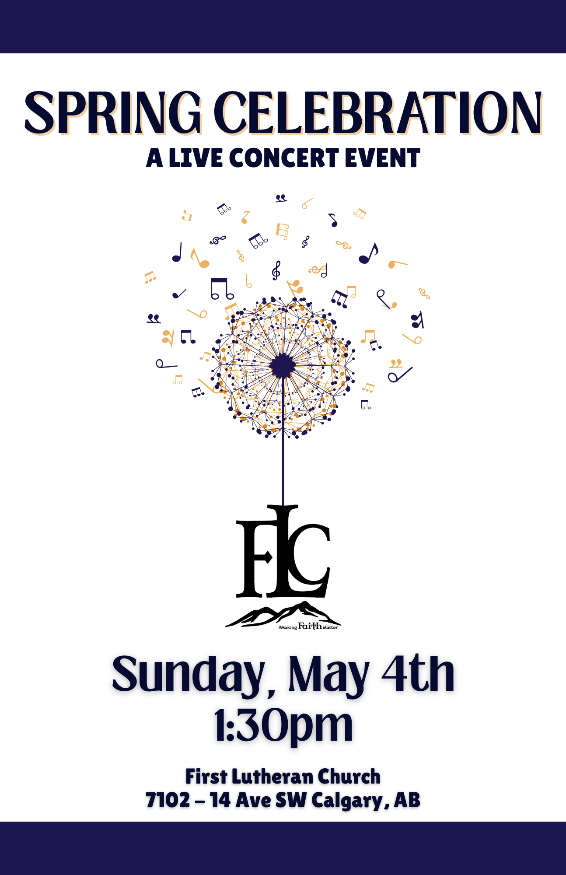

**SPRING CELEBRATION Concert**

**May 4th, 1:30 p.m.**

|  |  |
| --- | --- |
| **Summer of ‘69** | Brian Adams (1985) |
| **Freefallin’** | Tom Petty (1989) |
| **Head Above Water** | Avril Lavigne (2019) |
| **Little Wonders** | Rob Thomas (2007) |
| **I Write the Songs** | Barry Manilow (1975) |
| **What About Us** | P!nk (2017) |
| **Total Eclipse of the Heart** | Bonnie Tyler (1983) |

**--------------------Intermission ~15 minutes--------------------**

|  |  |
| --- | --- |
| **Rise Again** | The Rankin Family (1993) |
| **Free** | Zac Brown Band (2008) |
| **Leave a Light On** | Papa Roach (2022) |
| **Here Comes the Sun** | The Beatles (1969) |
| **Don’t Stop Believin’** | Journey (1981) |
| **Take Me Home, Country Roads** | John Denver (1971) |

**MUSICIANS**

|  |  |
| --- | --- |
| Yvonne Broadfield  FLC Worship Director | Voice/Guitar |
| Leah Craig | Piano/Voice |
| Leane EL Haddaoui | Voice |
| Garth Christiansen | Guitar/Voice |
| Wayne Hoff | Piano |
| David Perks | Drums |

Our Music team loves playing music together and wanted to do MORE of it! Everyone brought forward a few favourite songs which have made up today’s set list. We hope you enjoy!

*If you are interested in getting involved in our music ministry, please reach out to* ***Yvonne*** *at worship@makingfaithmatter.ca  
She’d love to meet with you and to invite you to join us for a rehearsal.***__________________________________________________**

**Emcee** –Pastor Phil Holck

**Sound** –Rainer Tonn

**Doors** – Brent Latimer, Sarah Shentaler  
________________________________

  
To donate to our Music Ministry,   
please scan this code to access   
FLC’s Canada Helps page

***Special Thanks***

*Thank you to everyone who helped support our musicians through rehearsals and scheduling and who came out to be our audience today!*

*We have so much fun doing what we’re doing and it’s through your encouragement that we continue to share and grow our musical gifts* ❤

**FLC’s Values**

***Uplifting*** *– because the story of Jesus is Good News!*

***Connecting*** *– because we don’t have to do life alone.*

***Inviting*** *– because that’s what Christians do.*

***Dynamic*** *– because love is alive.*

Rejoicing in God’s abundant grace, we at First Lutheran Church extend a special welcome to all in a world that is all too often an unloving and unwelcoming place. We welcome all who are seeking God’s love and grace. We welcome all because God welcomes all, regardless of race or culture, sexual orientation, gender identity, gender expression, or relationship status. We welcome all without regard to addictions, physical or mental health, imprisonment, socio-economic circumstances, politics, or anything that too often divides us.

Our unity is in Christ.

**Weekly Sunday Service – 11 a.m.**

