**Sunday, November 12, 2023**

**Worship 11:00am – Pentecost 24**

**Welcome & Announcements**

**Worship Songs**

**Prayer of the Day**

**Children’s Message**

**Scripture: Matthew 25:1-13** *Spark Bible*

**Prayers of the People**

**Fellowship Time**

**Offering & Worship Song**

**Scripture: Matthew 25:1-13** *NRSV*

**Reflection**

**Song of the Day**

**Lord’s Prayer**

**Sending Song**

**Blessing**

* **Worship services are intended to welcome children and their families into time with God. Children are welcome to stay with parents for worship.**
* **Power Zone (Sunday School) – PowerZone will NOT be meeting today, so the teachers can enjoy the long weekend with family.**
* **Today’s story is – “Five Were Ready, Five Were Not”**

* **Prayer Support: Requests for prayer or pastoral needs can be made in confidence via email:** [**prayer@makingfaithmatter.ca**](mailto:prayer@makingfaithmatter.ca)

**November’s music has been sponsored by Betty & Gordon McRae to celebrate their daughter Marla’s birthday**



**November’s hospitality has been sponsored by Irene Campbell in memory of Grant. **

**November’s PowerZone has been sponsored this month in honour of Marissa’s & McKenzie’s birthday**



**November’s**

**bulletin has been sponsored by**

**Irene Campbell in memory of Darcie.**



**#MakingFaithMatter**

**For the month of November First Lutheran Church will be accepting donations for Lutheran Campus Ministry, LCM, if you wish to add extra to your normal offering this month just put LCM and the amount on your envelope.**



**Consider sponsoring the bulletin, hospitality, music or PowerZone for a special occasion or “just because”.**

**sponsorship sheets are on the bulletin board in the lobby under the clock.**



It is time to renew your **Canada Lutheran** **Magazine**. Subscriptions must be received by October 31st if you want to renew or start receiving this terrific magazine. We have a discounted rate of $18.11 for a year. Make cheques payable to First Lutheran Church. For more information please see Liz.

It is time to renew your **Canada Lutheran** **Magazine**. Subscriptions must be received by October 31st if you want to renew or start receiving this terrific magazine. We have a discounted rate of $18.11 for a year. Make cheques payable to First Lutheran Church. For more information please see Liz.

**We are still collecting member registration forms.**

**Please fill out a form if you have not done so yet and put it in the baptismal font or on the offering plate.**

**Filling out the form ensures that Kelly has your correct information for the church directory and for tax receipts. All information can be kept confidential if you wish it to be.**

**Did you know that there are many ways you can give your tithe at**

**First Lutheran Church?**

**At service you can give your offering by cheque, cash or credit card.**

**You can also**

**e-Transfer your donation to** [**kelly@makingfaithmatter.ca**](mailto:kelly@makingfaithmatter.ca)

**Donations can also be done thru PAR (preauthorized remittance)**

**or by donating stock to**

**First Lutheran Church.**

**If you have any questions about donating please talk to Kelly.**



**Soup Social is this Thursday, November 16th**

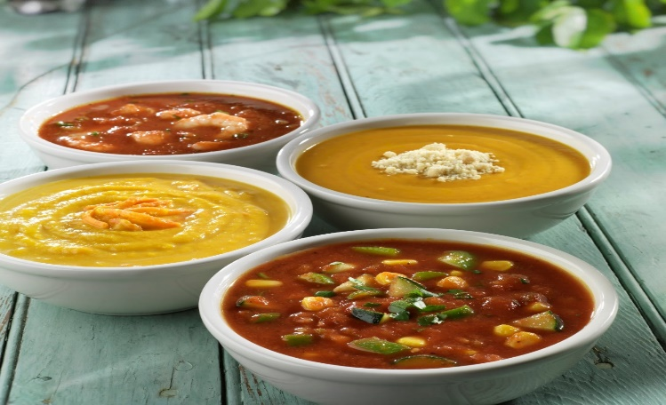

**Come and join us @ noon for soup and conversation.**

**Please signup or let Kelly know that you will be coming so we have enough soup☺**

**Bottle and can collection is ongoing.**

**Please drop your bottles off by the**

**shed closest to the garbage bin.**

**Your support is appreciated!**



**$663.10 has been collected in 2023.**

**First Lutheran’s Vision Statement.**

**First Lutheran Church is a dynamic**

**Christian community that is making faith matter**

**in a constantly changing world.**

Facebook.com/FirstLutheranChurchCalgary

@FLCCalgary

Youtube.com/FirstLuthCalgary

FLCCalgary

**Visit us online at www.makingfaithmatter.ca**

**Want to contact us?**

**Office Hours: Monday – Wednesday, 10am-3pm**

**Office Phone 403-242-4544**

**Phil –** Pastor: Local 206 Cell number: 403-813-6797

[**phil@makingfaithmatter.ca**](mailto:phil@makingfaithmatter.ca)

**Kelly** – Financial Assistant & Property Manager:Local 207

Christmas Eve Candlelight Services

December 24th

at 3, 5 and 7pm.

Communion will

be served at all

three services.

All are welcome.

[**kelly@makingfaithmatter.ca**](mailto:kelly@makingfaithmatter.ca)

**Yvonne –** Worship Director: Local 202

[**worship@makingfaithmatter.ca**](mailto:worship@makingfaithmatter.ca)

**Sarah** – Youth Co-ordinator

[**youth@makingfaithamtter.ca**](mailto:youth@makingfaithamtter.ca)

**Council –** Council Members

[**council@makingfaithmatter.ca**](mailto:council@makingfaithmatter.ca)

**Prayer –** Prayer Chain

[**prayer@makingfaithmatter.ca**](mailto:prayer@makingfaithmatter.ca)

**First Lutheran Church**

**7102 – 14th Avenue SW**

**Calgary, Alberta T3H 4G7**

**Tel: 403-242-4544**

[**www.makingfaithmatter.ca**](http://www.makingfaithmatter.ca)